CMIS102 Homework Assignment 1

Student Name: Reece Zunino
Class/Section: CMIS102
Professor Name: David Castillo
Assignment due date: January 25, 2015

Problem Definition: Calculate the usable area in square feet of a house. Assume that the house has a maximum of four rooms, and that each room is rectangular.

- Problem Analysis – This section describes the problem analysis of the assignment.
- Objective: Devise a program that calculates the usable area of a house. This is minimally what is being requested.
- Outputs:
  - Display Total Usable Area of the House:
    - TotalArea (as a Float variable)
- Display Total Usable Area of the Room:
    - TotalAreaRoom1 (as a Float variable)
    - TotalAreaRoom2 (as a float variable)
    - TotalAreaRoom3 (as a float variable)
    - TotalAreaRoom4 (as a float variable)

- Inputs:
  - Collect input data on the dimensions of each room from the user.
    - LengthRoom1 (as Float variable)
    - WidthRoom1 (as Float variable)
    - LengthRoom2 (as Float variable)
    - WidthRoom2 (as Float variable)
    - LengthRoom3 (as Float variable)
    - WidthRoom3 (as Float variable)
    - LengthRoom4 (as Float variable)
    - WidthRoom4 (as Float variable)

- Calculation Approach:
  - Total Area Room 1 = Length of Room 1 x Width of Room1
    - TotalAreaRoom1 = LengthRoom1 * WidthRoom1
  - Total Area Room 2 = Length of Room 2 x Width of Room2
    - TotalAreaRoom2 = LengthRoom2 * WidthRoom2
  - Total Area Room 3 = Length of Room 3 x Width of Room3
    - TotalAreaRoom3 = LengthRoom3 * WidthRoom3
  - Total Area Room 4 = Length of Room 4 x Width of Room4
    - TotalAreaRoom4 = LengthRoom4 * WidthRoom4
  - Total Area = Sum of the Area of the Four Rooms
    - TotalArea = TotalAreaRoom1+ TotalAreaRoom2+ TotalAreaRoom3+ TotalAreaRoom4

- Program Design – This section describes the program design used to solve the problem.
- Hierarchy Diagram: For this Problem, the design will be organized into the following distinct modules; Input, Calculation, and Output as depicted in the following Hierarchy Diagram:

Main Module
Input
Module
GetData
Calculation
Module
CalculateArea
Output
Module
DisplayArea

  - Main Module (main) – Controls program execution including start and end. Declare all variables in this section.
    - Declare LengthRoom1, WidthRoom1 As Float
    - Declare AreaRoom1 As Float
    - Declare LengthRoom2, WidthRoom2 As Float
    - Declare AreaRoom2 As Float
    - Declare LengthRoom3, WidthRoom3 As Float
    - Declare AreaRoom3 As Float
    - Declare LengthRoom4, WidthRoom4 As Float
    - Declare AreaRoom4 As Float
    - Declare TotalArea As Float

  - Input Module (GetAreaData) – Prompts the user for the Length and Width of all Rooms in the House. Also initializes the Length and Width in Feet for the Area of the Room’s.
    - Input LengthRoom1, WidthRoom1
    - Input LengthRoom2, WidthRoom2
    - Input LengthRoom3, WidthRoom3
    - Input LengthRoom4, WidthRoom4
    - LengthRoom1 10’, WidthRoom1 15’
    - LengthRoom2 10’, WidthRoom2 10’
    - LengthRoom3 13’, WidthRoom3 13’
    - LengthRoom4 12’, WidthRoom4 10’

  - Calculation Module (CalculateArea) – Applies the formulas identified in the Analysis Phase to compute the Total Areas of all Rooms and the Total Area for the House.
    - TotalAreaRoom1 = LengthRoom1 * WidthRoom1
    - TotalAreaRoom2 = LengthRoom2 * WidthRoom2
    - TotalAreaRoom3 = LengthRoom3 * WidthRoom3
    - TotalAreaRoom4 = LengthRoom4 * WidthRoom4
    - TotalArea = TotalAreaRoom1 + TotalAreaRoom2 + TotalAreaRoom3 + TotalAreaRoom4

  - Output Module (DisplayArea) – Displays the results of the program that were specified in the Analysis Phase
    - Output TotalArea
    - Output AreaRoom1
    - Output AreaRoom2
    - Output AreaRoom3
    - Output AreaRoom4

  - Flow Diagram – The Raptor flow diagram illustrates the logic flow of the program as follows:
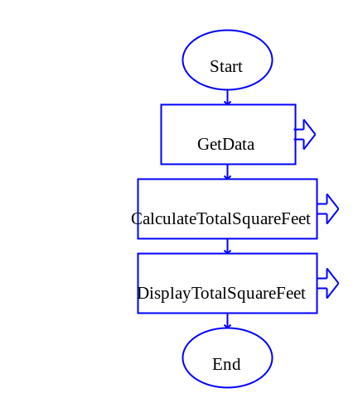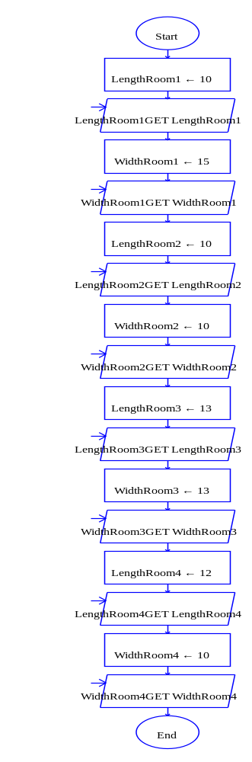
Main Module Get Data Module

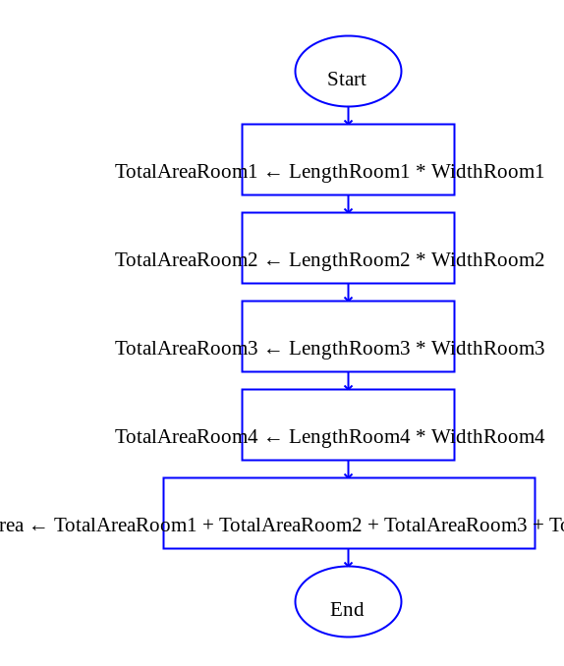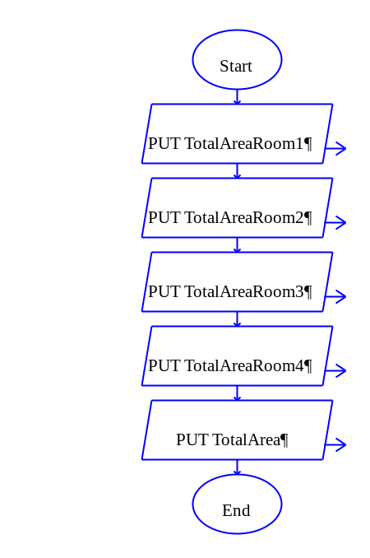
Calculate Total Area and Display Total Area Totals Modules

Raptor Data:
    - 150
    - 100
    - 169
    - 120
- 539
----Run complete. 37 symbols evaluated.----

- Program Pseudocode – This section describes the program pseudocode used to solve the problem. I have attached a programming template for you to shape your implementation:
// Total Area Calculator for Usable Square Footage
// Programmer: Reece Zunino
// Version 1.0, 1/24/15
// This computes the Total Square Feet of each individual Room and the
// total Area of the Home.

Main module
// Declare the Dimension Variables
Declare LengthRoom1, WidthRoom1 as Float
Declare LengthRoom2, WidthRoom2 as Float
Declare LengthRoom3, WidthRoom3 as Float
Declare LengthRoom4, WidthRoom4 as Float

// Declare the Area Variables
Declare AreaRoom1, AreaRoom2, AreaRoom3, AreaRoom4 as Float

// Declare the Total Area
Declare TotalArea as Float

// Now call the module for acquiring the program data
// and setting the values on the above declared variables
Call GetData module

// Call the module for performing the sales calculations
Call CalculateArea module

// Display the results of the sales calculations
Call DisplayArea module

End Program

// GetData Module is designed to acquire Length and Width of all Rooms
GetData module
// Prompt the user for the dimensions of each room
Write "Enter the length and width of Room1"
Input LengthRoom1, WidthRoom1

// Prompt the user for the dimensions of each room
Write "Enter the length and width of Room2"
Input LengthRoom2, WidthRoom2

// Prompt the user for the dimensions of each room
Write "Enter the length and width of Room3"
Input LengthRoom3, WidthRoom3

// Prompt the user for the dimensions of each room
Write "Enter the length and width of Room4"
Input LengthRoom4, WidthRoom4

// CalculateArea module computes the total area of each room to total the // Square feet of each individual room and totaling all rooms to give the // Total Square Footage of the House
CalculateArea module
// Compute the individual areas of each room
Set AreaRoom1 = LengthRoom1 * WidthRoom1

// Compute the individual areas of each room
Set AreaRoom2 = LengthRoom2 * WidthRoom2

// Compute the individual areas of each room
Set AreaRoom3 = LengthRoom3 * WidthRoom3

// Compute the individual areas of each room
Set AreaRoom4 = LengthRoom4 * WidthRoom4

// Compute the total area
Set TotalArea = AreaRoom1 + AreaRoom2 + AreaRoom3 + AreaRoom4

// DisplayAera module outputs the total Square Feet for each room and for // the Total Square feet of the House
DisplayArea module
// Display the total area of the house to the user

// Display the individual room areas

- Program Test Table –

Test Case # | Input: | Expected Output:
1 | Room1: length=10, width=15;  Room 2: length=10, width=10;  Room 3: length=13, width=13;  Room 4: length=12, width=10 | 539 square feet
2 | Room1: length=22, width=27;  Room 2: length=25, width=30;  Room 3: length=26, width=29;  Room 4: length=15, width=18 | 2368 square feet
3 | Room1: length=19, width=34;  Room 2: length=29, width=20;  Room 3: length=32, width=32;  Room 4: length=22, width=42 | 3174 square feet

